FN: Chukwu Irele Group:KH-128iae

Date:24 - 12 - 2019

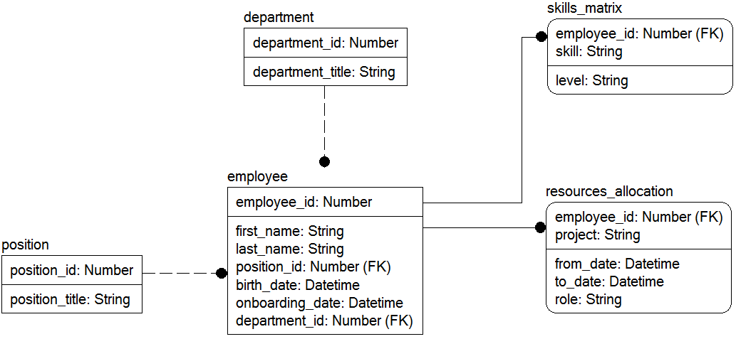

Modify the data model according to requirements below:

(result model must correspond to the 3NF)

1. Modify the data model to provide storing data about fired employees, considering the date and reason.

Solution :

